Automatic Rotary Premade Pouch Packing Machine
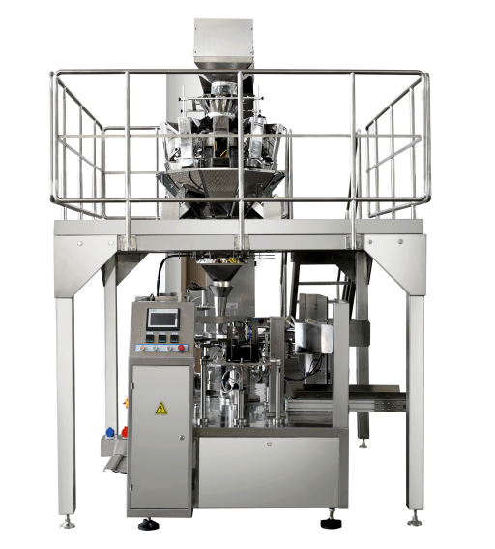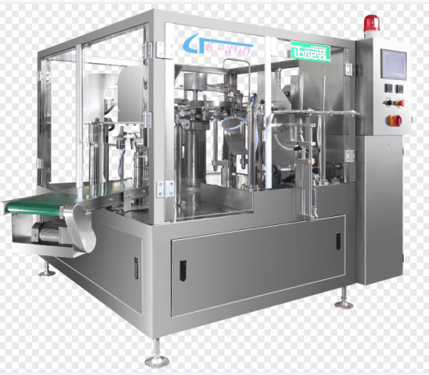

The complete system include:
- Z-type bucket elevator/Inclined belt conveyor/Screw feeder
- Multihead combination weighing scale/Auger filler/Linear weigher/Volumetric cup filler
- Supporting platform
- Rotary premade pouch packing machine

Options
- Check weigher
- Metal detector
- Rotary table
- Automatic secondary packing system
- Robotic palletizing system

Application:
Rotary pouch filler and sealer is ideal for packaging granular, powders,liquid or bulk materials into a variety of premade pouches.

FEATURES
- Self diagnose function: when there is no pouch or pouch open error, machine will not fill and seal. So that the bag can be used again, avoid wasting packing materials and raw materials.
2.Auto alarm or stop when there is something wrong with air pressure or heating elements.
3.The width of the bags could be adjusted by electrical motor. Press the control-button could adjust the width of clip, easily operate, and save time.
4.The part where touch to the materials is made of stainless steel and according with the request of GMP.

Technical parameter:
Model | ZR8-200 | ZR8-300
Bag size | W:80-200mm L:100-300mm | W:180-300mm L:200-450mm
Working Station | 8-working station | 8-working station
Bag Material | Laminated film/pe/pp | Laminated film/pe/pp
Bag Pattern | Stand-up with zipper & spout, stand-up, flat bag | Stand-up with zipper & spout, stand-up, flat bag
Max Filling Weight | 2000g | 5000g
Filling Accuracy | 0.5-1.5% | 0.5-1.5%
Packaging Speed | 10-60 bags/min | 10-45 bags/min
Voltage | 380V 3Phase 50/60Hz | 380V 3Phase 50/60Hz
Total Power | 3.5Kw | 3.5Kw
Compressed Air | 0.65Mpa, 0.6 m³/min | 0.65Mpa, 0.6 m³/min

